Unit 6 ~ Learning Guide Name: ______________________________
Instructions:

Using a pencil, complete the following notes as you work through the related lessons. Show ALL work as is explained in the lessons. You are required to have this package completed BEFORE you write your unit test. Do your best and ask questions if you don’t understand anything! Circuits:
- What is current? Rate of change of charge with time

- Explain how conventional current would be defined differently if early scientists understood that the current they were “playing with” really was. It would be defined as the effect of positive charge carriers and it flows from the positive terminal to negative

- Why are electrons, rather than protons, the principle carriers of charge in metal wires? Electrons are delocalized in metals forming a sea of electrons that conduct current but protons are only centered in the nucleus of an atom

- How is a conductor different then an insulator?
the conductor allows the energy (i.e., current ) to pass through it, whereas the insulator does not allow the energy to pass through it.

- Provide examples of 3 good conductors and describe some typical applications of each.

Aluminium used in making cookware
Copper used in making distribution wires
Iron used in electromagnets
- Provide examples of 3 good insulators and describe some typical applications of each.
Rubber used to prevent electric shocks in case of contact with open wires
Plastic used in coating naked wires
Glass is applied in the idea of fuses

- Resistors are most often used in a circuit for either _____controlling current flow___________________ or _____divide voltages___________________.

- Would the light turn on if the switch was closed in the following circuits? Draw arrows showing any expected current.

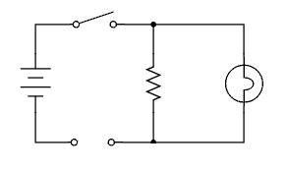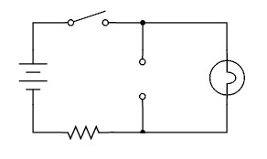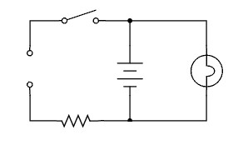
(A)No, the is no current (B)yes current is reaching the bulb (C) yes the bulb is directly connected with the source

- Draw a schematic for each of the following diagrams (below each):
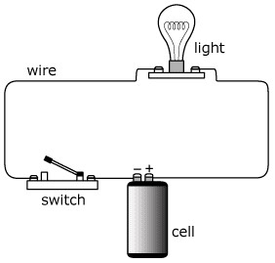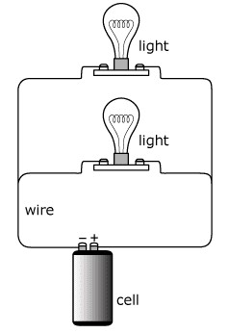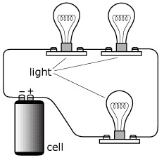

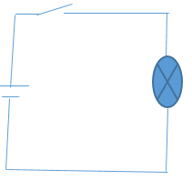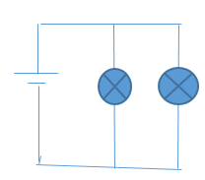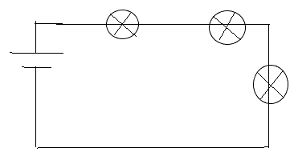

- Show how to make a circuit where two switches both need to be closed in order for the light to turn on. Include a schematic and some explanation.
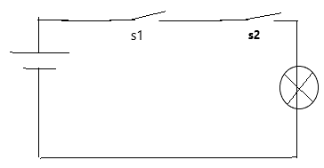
For current to flow to the bulb it has to go through the two switches

- Explain how to make a circuit where either of two switches has to be closed in order for the light to turn on. Include a schematic and some explanation.
The two switches should be in parallel such that if any is on the circuit is on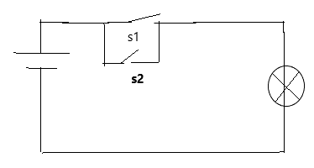

- Draw wires onto the following diagram to show how you would wire the following batteries if you had a light bulb that required 6V.

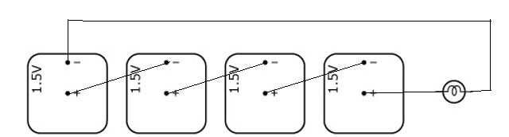
- Draw wires onto the following diagram to show how you would wire the following batteries if you had a light bulb that required 1.5V and you wanted to make the batteries last for a long time.

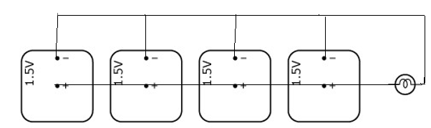
- Draw wires onto the following diagram to show how you would wire the following batteries if you had a light bulb that required 3V and you wanted to make the batteries last for a long time.

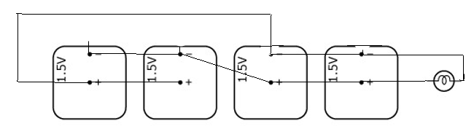
- What is the main wiring plan for houses to ensure that each receptacle and light socket is the same voltage (ie. approx. 120 V)? Include a schematic and some explanation.
Parallel connection ensures all devices operate at the same voltage

- Explain how a string of Christmas lights in series can use a single blinking bulb to make the whole string blink. Include a schematic and some explanation.
As the strip cools it bends back reconnects the post and relights the filament so the cycle repeats.whenever this blinker power is not lit the rest of the strand is not getting power so the entire strand blinks in unison
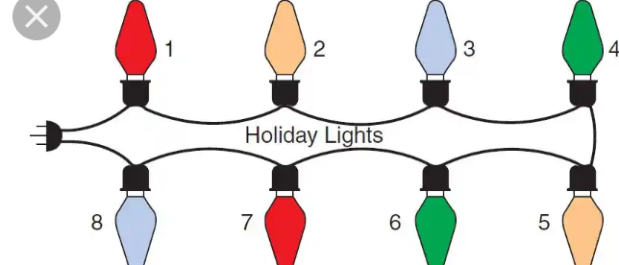

- A light bulb has 120 Ω of resistance. When switched on (in a house with 110 V), what is the current running through it?
I=v/r=110=120=0.92 A

- A 100 Watt light bulb operates on 110 Volts. What is the resistance?

P=v^2/r=> R=V^2/P=110*110/100=121Ω

- Include a diagram and explanation to describe why a voltmeter needs to be VERY high resistance.
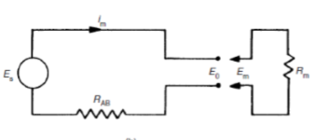
Voltage to be measured 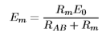 increasing Rm raises the ratio of em/eo to unity and thus Rm should be as large as possible to avoid it affecting the resistance of the string

- Include a diagram and explanation to describe why an ammeter needs to be VERY low resistance.
So that its resistance doesn’t cause a potential drop across it which reduces the potential of the resistor it is measuring its current
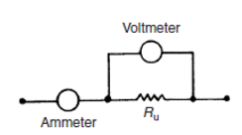

- If the voltage across a circuit is held constant while the resistance doubles, what changes occur in the circuit?

Current reduces to half the original value

- A small light bulb is connected to a 6 V battery and draws 2 A of current. What is the net resistance of the bulb?

R=V/I=6/3=3 Ohms

- A motor with an operating resistance of 32 Ω is connected to a voltage source. The current in the circuit is 1.5 A. What is the voltage of the source?
V=IR=32*1.5=48V

- Determine the amount of current going through a 50 Ω; resistor with a voltage of 120 V.

I=V/R=120/50=2.4A

- A wire wound resistor has a resistance of 200 ohms. What voltage applied between the terminals will produce a current of 0.08 amperes?
V=IR=200*0.08=16V

Circuit Protection:
- Describe the difference between fuses and circuit breakers.
Fuses burn up to cut the supply when the current is excess while circuit breakers turn off and are thus not destroyed when current is excess

- What is meant when we refer to a “short circuit?” direct connection of wires with no resistance

Series & Parallel:
- Resistors added in series _increase________________ the overall resistance.
- Resistors added in parallel ___reduce______________the overall resistance.
- Devices in series have the same ___current____________ running through them.
- Devices in parallel have the same ________voltage_________ drop across them.
- Use some sort of water-flow, water-slide, or traffic-jam analogy to explain/remember the previous 4 results. Draw and explain in detail.
flow machine
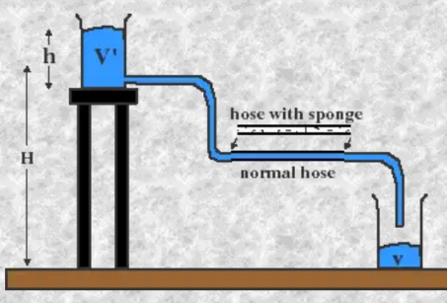
a normal hose and a sponge-clogged hose is used to simulate two different resistances. We discovered that, with the sponge-clogged hose (higher "resistance") it took longer for 300ml of blue water to fall into the lower beaker (less "current"). This is analagous to less current because we define current to be amount/time. In this experiment by analogy, more resistance led to more time for the same amount.

For a fixed "voltage," then, more resistance gives less current.

If one, instead, were to use the same sponge-clogged hose each time (fix "resistance"), but raise or lower the upper reservoir level to various heights each time (vary "voltage"), the amount of water flowing per unit time ("current") would vary in a manner proportionally to the upper reservoir height.

In other words, current would be proportional to voltage for a fixed resistance. This is reminiscent of the relationship between net force, acceleration and mass.

Do this experiment with real wires, resistors, and batteries and measure current and voltage. You would then see that the relationship between voltage (V), current (I) and resistance (R) is:
V=IR

Parallel Circuits
What will we measure if we replace our single drain hose with two? Will it take less, the same, or more time for 300ml of blue water to transfer?
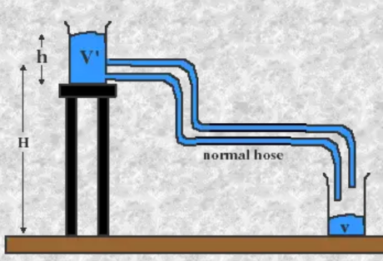

This experiment gives an analogy for parallel circuits, where electrons with the same push (voltage) have more than one path to follow. With more paths to follow and the same push as before, more current flows (300ml of blue water transfers in less time). According to Ohm's law, then, the effective resistance of the circuit is reduced. This also has implications for the power requirements of the circu

- If the current flowing through the following circuit was 2 Amps, what is the resistance R?
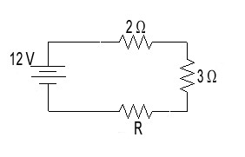 R=V/I=12/2=6=2+3+R R=1 OHM
- What is the current flowing through the following circuit if R = 11 Ω?
RT=2+3+11=16 I=V/R=12=16=0.75A
- What is the voltage, V, if the current flowing in the following circuit is 3.75 A?
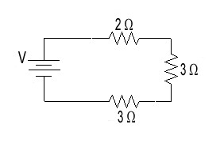 V=IR=3.75*8=30 V
- If you were to replace the 4 resistors in the circuit below with a single one, what resistance would it have to be? Hint – break down in steps, drawing each circuit.
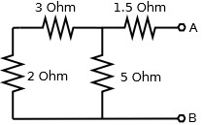
RT=2+3//5+1.5 =>RT=1.5+1/(1/5+1/5)= 4Ω

- If V = 12 volts, in the circuit below, what is the current, I (the current flowing through the main branch)? Hint – break down in steps, drawing each circuit.
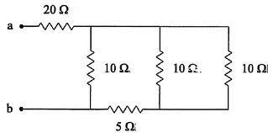
Rt=25.71 ohms
Current=12/25.71=0.47A
By current division for the 10 ohm resistors 0.6*10/30=0.2A WICH IS THE CURRENT IN THE MAIN BRANCH

- If V = 12 volts, in the circuit below, what is the current, I (the current flowing through the main branch)?
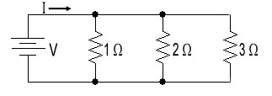
RT=1/(1/1+1/2+1/3)= 0.545Ω
I=v/r=12/0.545=22A

- When V = 6 volts, the current I = 18 A, the current through. What is the resistance R?
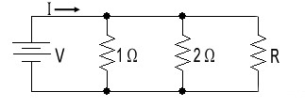
R=6/18=1/3 ohms=1/(1+1/2+1/R)
R=0.67Ω

- What is the equivalent resistance of the following circuit?
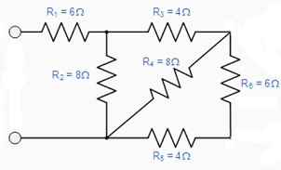
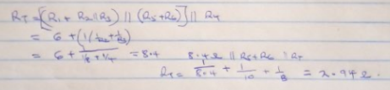

- If all of the resistors below are 20Ω resistors, what is the equivalent resistance? Show all work and draw your final simplified circuit using the equivalent resistance. Show steps.
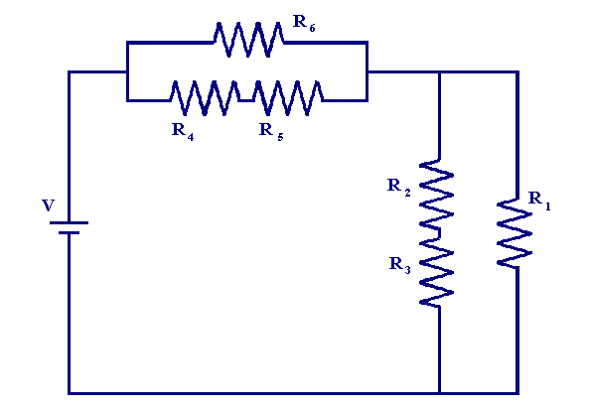
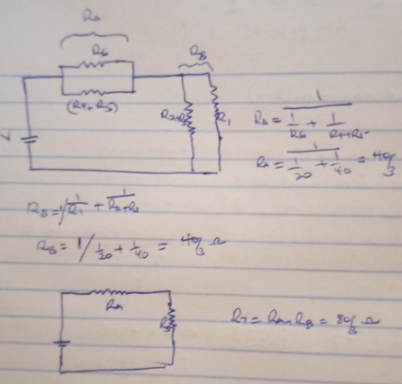

Kirchoff’s Laws:
- What is an easy-to-remember summary for each of Kirchoff’s laws?
KVL algeabraic sum of voltages in a loop is zero
KCL sum of currents in a node is zero

- The voltage provided by the battery for the circuit powering two lamps in series is 6V. If one of the lamps has a voltage of 2V, what is the voltage across the other?

4v

- What is the unknown current, I, in the following circuit?
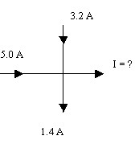 5+3.2-1.4=i=6.8A
- Determine the missing current(s) in each circuit.
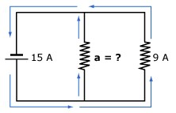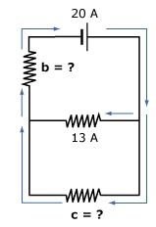
A=15-9=6A 20-13=C=B=7A

- Determine the missing voltages in the following circuits.
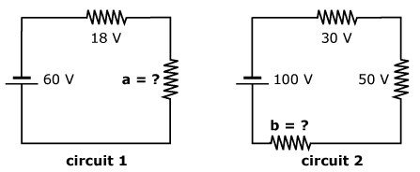
A=60-18=42v 100-30-50=b=20V
- Determine the missing voltages in the following circuits.
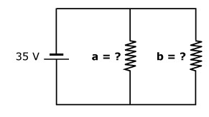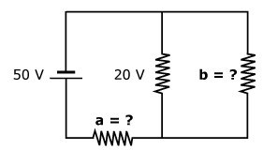

35=a=b= b=20 a=50-20=30V

- What the unknowns (current, voltage), in the following circuits?
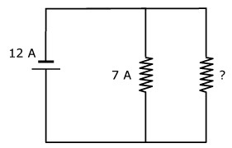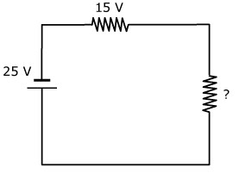

12-7=5A 25-15=10V

- Consider the circuit shown.
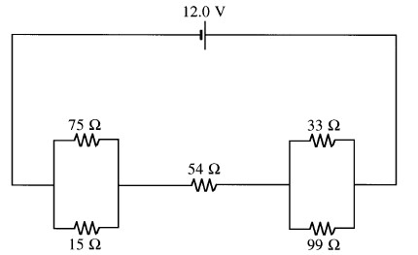
  - What is the equivalent resistance of this circuit? Show steps.
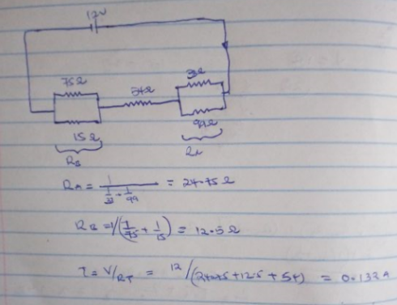

  - Simplifying circuits by using equivalent resistances often makes calculations of current or voltage easier. Let’s consider the following question: What is the current through the 54 Ω resistor? BEFORE we answer this let’s simplify the circuit.
    - Redraw the circuit so that we are only left with two resistors; the 54 Ω and the equivalent of the remaining resistors.
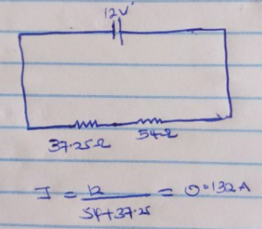

    - Solve the simplified circuit: What is the current through the 54 Ω resistor?

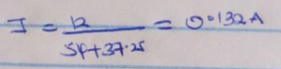

iii. How much power is dissipated in the 54 Ω resistor?

P=I^2R=0.132^2*54=0.94W

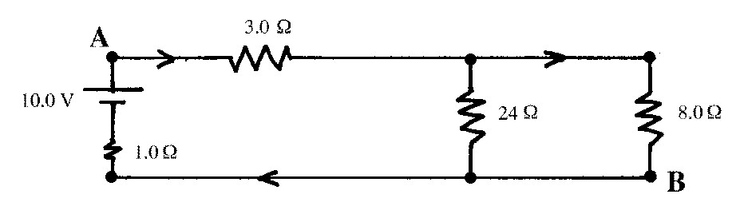
- Consider the circuit shown:

  - What is the equivalent resistance of the circuit? Show steps.

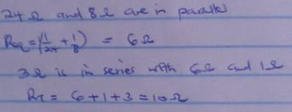

  - What is the total current leaving the battery?

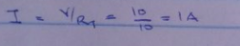

  - What current exists at A? What is the voltage across the 3Ω resistor? Why is the current the same as the total current?
1A. voltage across 3Ω resistor =3*1=3v. the resistor receives it from the source directly and it is equivalent to the total current

  - What is the potential difference between the ends of the 8.0  resistor? What current?

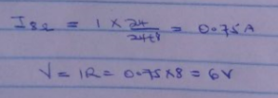

  - What is the current through the 24 Ω? The voltage?

By current division I24= I TOTAL *8/(24+8)=0.25A

  - Using Kirchoff’s Voltage Law and Current Law determine the voltage and current through the remaining 1 Ω resistor.
BY kvl 10-3-6-V1Ω=0
V1Ω=1 v
Kcl at the junction of 24 ohms and 8ohms and 1ohm
0.75+0.25-I_{1OHM}=0
I_{1OHM=}1A

- Determine all the voltages in the following circuit:
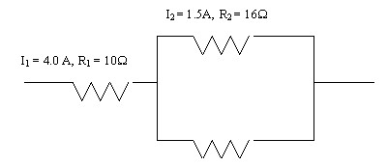
V2=I2*R2=1.5*16=24V
V1=I1*R1=40V

- Determine the voltage, Vx, if 2A passes through the 6 Ω resistor.
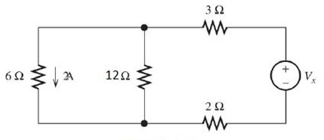

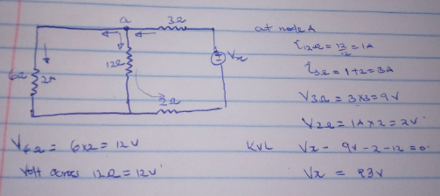

- Determine the voltage across the 6 Ω resistor.

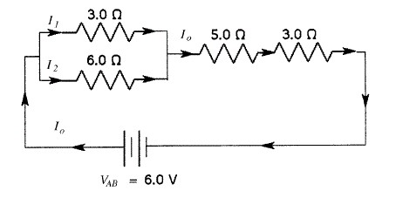

R_{t} parallel=1/(1/3+1/6)=2
Rt=2+5+3=10
I=6/10=0.6A
By voltage division V_{6ohm}=2/2+5+3)*6=1.2V

Terminal Voltage:
- Describe why people sometimes throw away perfectly good devices after they “check things out” and determine that the battery is good.
The device could have other defects such as short,easy drain of the battery etc

- A 1.5 V source has internal resistance of 1.0Ω , what current must flow through the cell so that the terminal voltage is equal to the EMF?
V=E-Ir, for emf to be equal to terminal voltage no current should flow
- Calculate the terminal voltage of the cell if its EMF is 1.5V, with internal resistance of 0.50 Ω and R=10 Ω
I=emf/(Rload+r)=1.5/10.5=0.1429A
V=E-Ir=1.5-0.1429*0.5=1.43v

- Power in a resistor is often dissipated as heat. Why does a battery heat up more when connected to a circuit with a low resistance?
Power loss is inversely proportional to resistance therefore a smaller resistor leads to higher power loss(p=v^2/R)

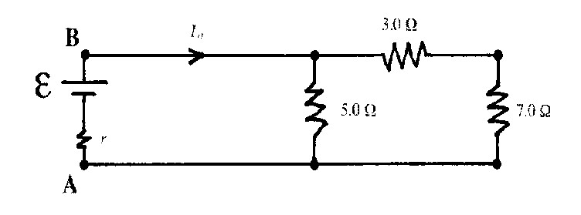
- In this circuit, the EMF of the battery is 6.0V while the terminal voltage (across A and B) is 4.6V.

  - What is the total current I_{o}?
Rload=10*5/10+5=3.333
Io=emf/(Rload)=4.6/(3.333)=1.38A

  - What is the internal resistance r?
6-4.6=Ir
1.4/1.38=r=1.014 ohm

Power:
- The unit for power is ___watt___________________.
- The greater the power of a device, the faster it uses up __energy___________________.
- Starting with P=VI, derive two others formulae for calculating power.
P=vi but i=v/R
Therefore p=v^2/R
P=VI but v=IR p=i^2R

- Find the voltage needed to run a 10 watt cordless phone that draws 0.25 amps of current.
V=P/I=10/0.25=40V

- A 2.2 kΩ resistor is rated at ‘½ W’. What is the highest voltage you could safely apply to the resistor without risking damage to it from overheating?
P=V^2/R
Therefore(p/R)^1/2=(0.5/2200)^0.5=0.015V

- A table lamp is wired so that only 0.5 A of current can flow through its wires before they overheat. What is the highest power light bulb that can be used in this lamp, if it is plugged into a 120 volt outlet?
P=VI=120*0.5=60W

- A TV draws 30 amps of current from a standard household 120 volt outlet. How much power does it consume?
P=VI=120*30=3600W

- Why is P=I²R the most commonly used formula for determining power lost due to heat?
Heat is lost in the form of resistance heating and we are not sure of the voltage across the resistor

- A 600 W electric heater is connected to a 120 V source. What current flows through the heater?
I=p/v=600/120=5A

- A portable hair dryer, plugged into a 110 V outlet, has a current of 10 A flowing through it. What is the power rating of the hair dryer?
P=VI=110*10=1100W

- A DVD player that is not being used still uses energy at a rate of 25 W. What current is passing through it if the DVD player is plugged into a 110 V electrical outlet?
I=P/V=25/110=0.2273A

- The European Union (EU) has banned the sale of 100 W filament light bulbs because about 92 per cent of the input energy is wasted as heat. What is their efficiency?
Efficiency= output/input*100=( 1-0.92)/1*100=8%

- A hair dryer has an energy input of 1500W and gives out 1300W of useful energy. What is the efficiency of the hair dryer?
Efficiency=output/input*100=1300/1500*100=86.7%

- Look at these energy diagrams. Work out the efficiency of each device.
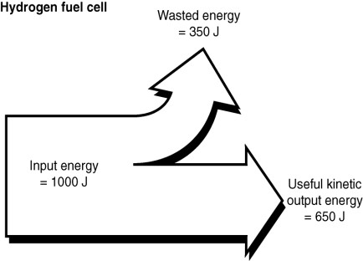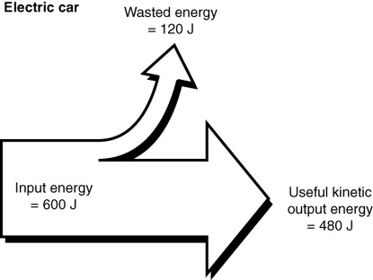

Hydrogen cell efficiency=650/1000*100=65% electric car 480/600*100=80%
Transmission Lines:
- At its most basic level transmission lines can be considered as a simple circuit depicted below:
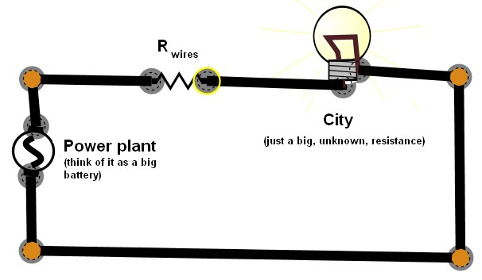

  - What type of circuit is depicted above? Series or Parallel?
series
  - What remains constant in this type of circuit?
current
  - R_{wire} is the resistance found in the transmission lines. We want the wires to remain as cool as possible since heat is considered a waste of energy (a loss). Discuss why it is better for a Power Plant to transmit 100 MW of power at a high voltage and low current (recall: P = VI) as opposed to a high current, low voltage.
High current leads to higher loss through resistance of the wires therefore lesser efficiency

  - If the Power Plant is delivering 5 x 10⁷ W of power to the lines using 2.5 x 10⁵ V, how much current is travelling through the lines?
I=p/v=5*10^7/2.5*10^5=200A

  - The resistance of the lines themselves is 2 Ohms. How must power is dissipated (used up) by the lines? This is considered to be the “Power Lost”.
P=I^2R=200^2*2=80KW

  - Therefore, how much of the original power ends up at the city? You’ll recall that efficiency is a ratio of output/input using either energy or power. What is the efficiency of the lines?
Power at the city = power generated –power lost during transmission
Plost=5*10^7-80000= 49.92MW

- Why are “step-up” and “step down” transformers used for transmitting power more efficiently? Explain the rationale for the transmission design shown.
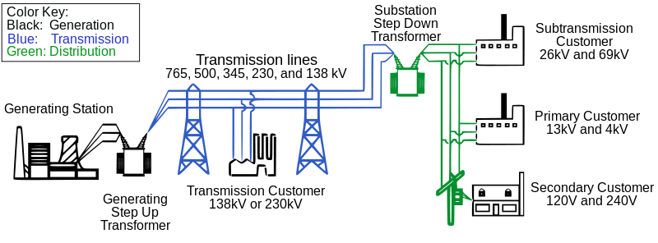

Step up raises the value of voltage to high values to minimize losses during transmission while step down reduces the value to usable values both domestically and in industries

- Suppose a company decides to ship 150 000 W over 2.0Ω transmission lines at 560 V. a) How much power is lost?
Power lost=v^2/r=560*560/2=156800

  - What is the efficiency of transmission?
Efficiency=output/input *100=(150000-156800)/150000*100=-4.533%

  - Compare the power lost above to the power lost in #1. Discuss which mode of power delivery (high voltage at low current OR low voltage at high current) is more efficient. Why? High voltage is recommended because current will be less therefore lost power will be less

- Transmitting electricity is most efficient when __voltage__ is high and ___current_________ is low.
- Transmitting electricity is most safe (in most ways) when ___current___________ is high and _________voltage___ is low.
- What are three ways in which electricity can be generated?
Through hydro turbines
From nuclear power
From wind turbines

- How is the electricity being generated for your home? A little research may be required.
From hydro turbines in dams
- Where is the last transformer found, prior to electricity entering your home? On a pole or in a box – quick description? Take a look around (you won’t need to open or touch anything).
300m away

- What are the current trends regarding electrical generation? Why?
Renewable technologies

- Calculate the efficiency of 25 000 W of power shipped at 500 V over 10 transmission lines.
Power loss=500^2/10=25000w
Output=25000-25000=0
Efficiency=output/input*100
0/25000*100=0%

- A power station delivers 455 kW of power at an input voltage of 4.00 x 10⁴ V to a factory through lines whose total resistance is 5.00 . If the same power was required, but the input voltage was reduced to 1.00 x 10⁴ V, by what factor would the power wasted in the lines be multiplied? Show ALL work!
Power lost ratio=(v₁^2/R)/(V₂^2/R)=(4*10^4)^2/(1*10^4)^2=16

Answers:

Circuits
7)converting energy, controlling current 8)N,Y,Y 12)3inseries 13)4inparallel 14)2parallel sets of 2 in series 15)parallel sets of “switches and resistors(lights)” and “receptacles” 16)series 17)0.92A
18)121Ω 19-20)not change circuit during reading-explain 21)current/2-explain 22)3Ω 23)48V 24)2.4A
25)16V

Series & Parallel
1) increase 2) decrease 3)current 4)voltage 6)1Ω 7)0.75A 8)30V 9)4Ω 10)0.48A 11)22A 12)0.67Ω
13)10.1Ω 14)26.6Ω
Kirchoff’s Laws
2) 4V 3) 6.8A 4)6A,7A 5)42V,20V 6)35V,35V 7)5A,10V 8)a) 91.25Ω b)0.132A,0.934W
9) a)10Ω b)1A c)1A, 3V d)6V,0.75A e)0.25A,6V f)1V,1A 10)40V24V,24V 11)27V 12)1.2V
Terminal Voltage
2) 0A 3) 1.43V 4) higher current 5) a) 1.38A b) 1.01Ω

Power
1)Watts 2)energy 4)40V 5)33V 6)60W 7)3600W 9)5A 10)1100W 11)0.23A 12)8% 13)87% 14)65%,80%

Transmission Lines
1a)series b)current c)efficiency,explain d)200A e)80000W f)4.99x10⁷W, 98% 3)1.44x10⁵W b)4.2% 4)voltage,current 5)current,voltage 10)0% 11) 16X

